

**Table of Contents**

Preface/Author’s note 1

Who this book is for? 1

Features Added in Recent Releases 2

To Come in Future Releases 2

Protocol Overview 3

EEG Background 3

Functional Connectivity 5

EEG Bands 5

Obtaining Consent 5

Taking Head Measurements 6

Starting a Recording I 8

Electrode Cap Placement 11

Application Tips & Tricks : Pinch-N-Pull method 11

Starting a Recording II 13

Data Review & Cleanup 16

Equipment Cleaning 17

The Remainder of this document is extra text which I might add/review in future documents. 21

xElectrode Cap Placement 22

xHandling Participants 23

Appointment Prep 23

Bring the participant in 23

Explain the process to the participant 23

If they seem nervous 24

Setting up 24

Plugging in electrodes, preparing for the task 25

After practice block 25

Between trials 26

Break 26

Tips 26

xRecording A Session 26

xUsing the PC and Software 28

# Preface/Author’s note

This “guide” was created as a personal reference for myself as I spent time responding to technical difficulties that arose on projects within the Anesthesiology department under the tutelage of Dr. Phillip Vlisides. As problems arose, I would note them in this document and refer to it from time to time. As you progress you will find that this guide is no longer necessary for you but it is a good starting point for beginners. If you find yourself facing a problem that is not noted here please email me your problem and the solution (if possible). Feel free to add things in the “To come in Future Releases” section. I recommend enabling the Navigation Pane in Microsoft Word to find key elements swiftly.

This guide is meant to introduce quantitative electroencephalographic methods and techniques within the Anesthesiology department. This document is not intended to provide a thorough background of terms utilized in this branch of research. Rather it is meant to introduce new researchers to some of the techniques in the acquisition of data.

This book contains a compilation of knowledge from several different sources, for this reason I consider myself an editor of knowledge, rather than an author. No copyright infringement is intended. Nevertheless, I strongly recommend this guide be utilized for **internal use only**. As the 1st edition of this guide, I anticipate errors and I welcome feedback. You may contact me by email at alapo@umich.edu.

# Who this **book** is for?

Technicians and Clinicians seeking a guide on how to properly collect qEEG data. It is not intended to introduce analytic techniques. For our purposes all we need to be able to do is email Duan Li, she will take over from there. We will however present some basic technical information to familiarize you with some of the frequently used terminology within this branch of research.

# Features Added in Recent Releases

1. Added screenshots of the Cognionics setup in “Recording a session” section
2. Section/Photos on how to clean the cap.

# To Come in Future Releases

1. Review content from Gehring lab and Phil’s protocols and delete/replace some of the data. Some if it is not pertinent for most of these studies (particularly the ERP stuff).
2. Add screenshots/video of the setup in Cognionics
3. Add photos of
   1. What to do when all the sensors seem off
   2. Appropriate amount of gel
   3. Where to place ear electrodes 🡪 show how to use your index for feel for correct placement
   4. Ask Phil if he wants me to add/change to “Clinical Neuroscience Research”
4. Add basic description of different EEG analysis
   * 1. Power Spectra
        1. Different frequencies.
     2. Microstates
     3. Functional Connectivity
     4. SLORETA
5. Add plug in the battery
6. Add check to see the power levels on the battery within the cognionics program.

# Protocol Overview

The steps to research within this team can fluctuate slightly from study to study however the general steps remain quite similar. Below is an example from our recent “Cortical Connectivity During Consciousness and Anesthesia” study.

We will go over each of these in greater detail below.

# EEG Background

The 10/20 system of International 10/20 system is an internationally recognized method to describe the location of scalp electrodes.

The system is based on the relationship between the location of an electrode and the underlying area of the cerebral cortex. The numbers ‘10’ and ‘20’ refer to the fact that the distances between adjacent electrodes are either 10% or 20% of the total front-back or right-left distance of the skull. An image of a montage for the Cognionics system is shown below in figure 1.

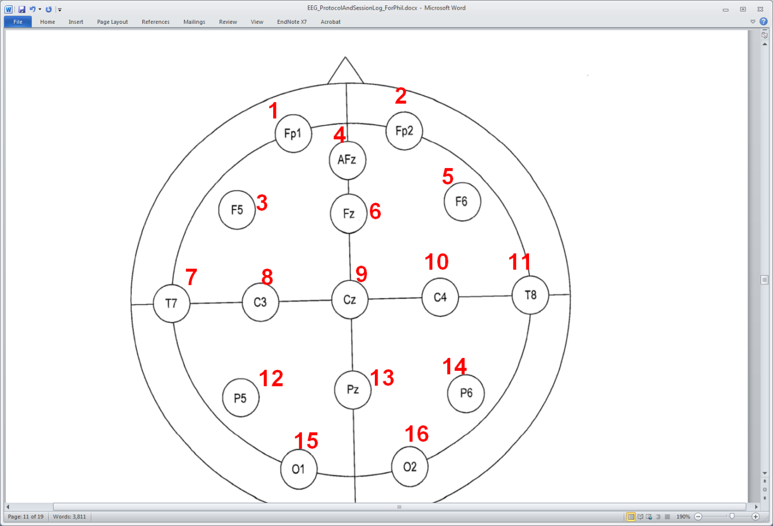

**Figure 1.** 10-20 Layout of the Cognionics HD-72 EEG

Each site has a letter to identify the lobe and a number to identify the hemisphere location.

|  |  |
| --- | --- |
| Electrode | Lobe |
| F | Frontal |
| T | Temporal |
| C | Central* |
| P | Parietal |
| O | Occipital |

No central lobe exists, the “C” letter is used for identification purposes only. The ‘z’ (zero) refers to an electrode placed along the midline. Even numbers refer to electrodes on the right hemisphere whereas odd numbers refer to electrode positions on the left hemisphere.

## Functional Connectivity

Functional connectivity

## Microstates

The routine EEG is traditionally analyzed in the frequency domain, and more recently, quantitative spectral analysis has gained favor especially in the ICU setting. An alternative method of analyzing EEG is by means of topographic maps in a method called microstate analysis, which analyzes the EEG topographic maps at millisecond intervals. This method captures the high temporal resolution of the EEG, coupled with the spatial information of EEG. When analyzed using EEG microstates, the EEG can be summarized in a limited number of prototypical topographic configurations that are stable for an average period of 100 milliseconds and rapidly transition to other configurations until reaching another steady microstate (Lehmann et al., 1987). Using cluster analysis, studies have found that 4 distinct microstates (Figs. 1A–1D) explain the majority of the EEG variance (Koenig et al., 2002; Pascual-Marqui et al., 1995). Map A has a left occipital to right frontal orientation, map B has a right occipital to left frontal, map C has a frontal to occipital orientation, and map D has a frontocentral maximum (Brodbeck et al., 2012). These 4 microstates remain consistent across different age groups, and they seem to evolve with age with most of the microstate changes occurring at 12, 16, and 21 years of age (Koenig et al., 2002). The same microstates can be found in wakefulness and sleep, and they seem to increase in stability during slowwave sleep (Brodbeck et al., 2012). The stable microstates are thought to represent the basic building blocks of mentation or “atoms of thought” (Lehmann and Michel, 2011).

With the advent of EEG-fMRI technology, correlations of microstates with specific blood oxygenation level dependent (BOLD) activation patterns on MRI have been performed. Britz et al. (2010) showed that microstate A corresponded to BOLD activation in the superior and middle temporal gyri, B to the extrastriate visual cortex, C to the cingulate, bilateral inferior frontal lobes, and insula, and D to the right lateral frontal and parietal lobes. These activation patterns have been linked to phonologic processing, visual processing, saliency, and reflexive attention and concentration, respectively. Musso et al. (2010) did not limit the number of microstates to four and were able to correlate specific microstates with a number of previously identified resting state networks on fMRI. Similar findings were also reported by a third group as well, and this time linking 13 microstates to 10 BOLD resting state networks (Yuan et al., 2012). Further studies showed that the EEG microstates were scale free, which would explain the ability of these studies to correlate EEG and fMRI data that have different temporal resolutions (Van de Ville et al., 2010).

EEG microstates have already been analyzed in a number of diseases, and microstate characteristics have been found to be altered in patients with Alzheimer disease or cognitive decline (Dierks et al., 1997; Stevens and Kircher, 1998), untreated patients with panic disorder (Kikuchi et al., 2011), and patients with schizophrenia and auditory hallucinations (Kindler et al., 2011). Similar findings were also replicated in a study looking at patients with schizophrenia, frontotemporal dementia and Alzheimer disease and control subjects (Nishida et al., 2013).

## EEG Bands

<http://itsusync.com/different-types-of-brain-waves-delta-theta-alpha-beta-gamma>

# Obtaining Consent

In all instance you will be required to acquire consent from your participant. During this time, it can be a good idea to bring an EEG cap with you to demonstrate to the participant the equipment that will be used. It can help put the participant at ease knowing what he/she is signing up for.

In general, the team should not record from people who have braids, ponytails, dreads, or very thick hair. You will not get a good recording. People should be prescreened for this. It’s really not worth your time. You should not record from people who have badly fitting heads (really small or really big, or too much in-between sizes). You will not get a great recording easily in these cases, though they may be few.

During this time, you’ll want to explain the purpose of the study. If the participant agrees to participant it’s a perfect time to take some head measurements (see section below). These will be used to know which cap size to use and it’s also a great measure to record for future analyses. Below is a guide on taking head measurements.

# Taking Head Measurements

Four anatomical landmarks are used for the essential positioning of the electrodes: first, the nasion which is the point between the forehead and the nose; second, the inion which is the lowest point of the skull from the back of the head and is normally indicated by a prominent bump; the preauricular points anterior to the ear.

**Step 1:** **Measure from Nasion to Inion**

1. Take a measuring tape and use the centimeter side.
2. Measure over the center line of the scalp, from the Nasion (bridge of the nose) to the Inion (occipital protuberance). Note the total length.
3. For our example, the total length is 36 cm.

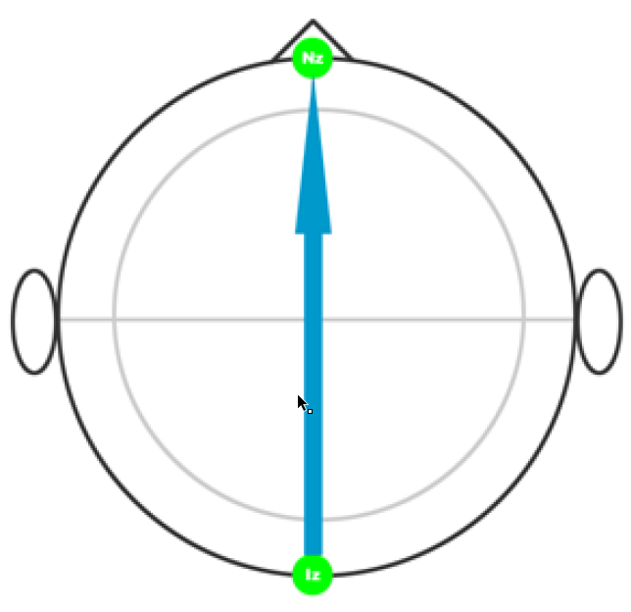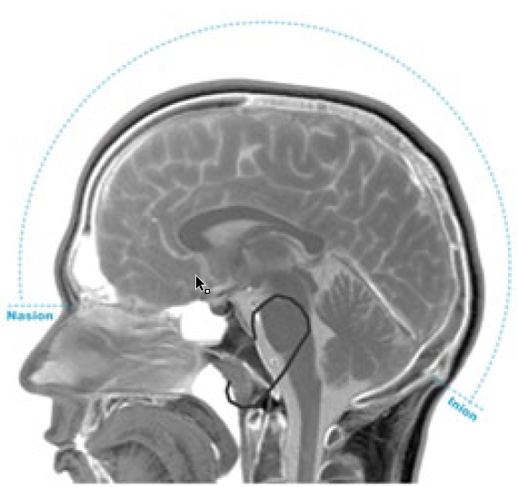

**Finding the Inion:** if you run your finger up the back of the neck, you will encounter a depression with the ridge of the protruding inion just above it

**Step 2:** **Properly Placing Cz**

1. Measure and mark 50% of your total. This is where Cz should line up when you place the cap
2. In this example 36 cm / 2 = 18 cm

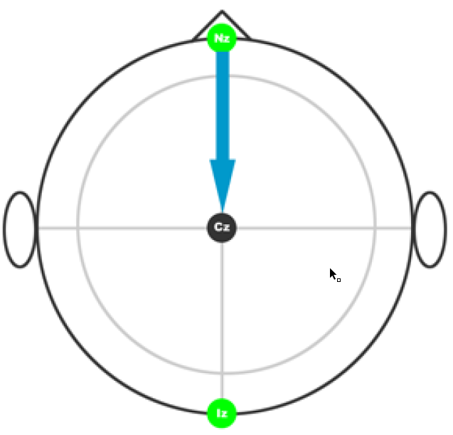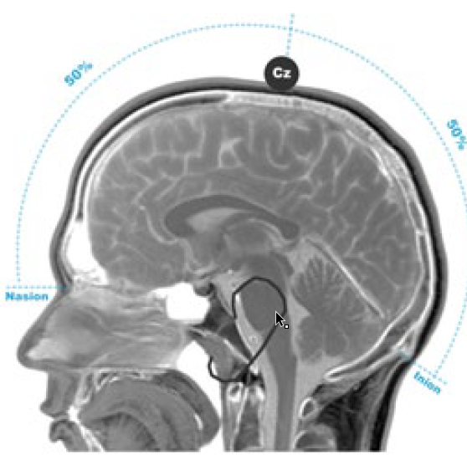

**Step 3:** **Measuring Width (preauricular points)**

1. Measure from preauricular point to preauricular point.
2. Lightly run your finger up and down just anterior to the ear
3. The indentation above the zygomatic notch is easily identified
   1. Opening the mouth slightly makes it easier to find the exact location
4. Note the total length
5. For our example it is 38 cm.

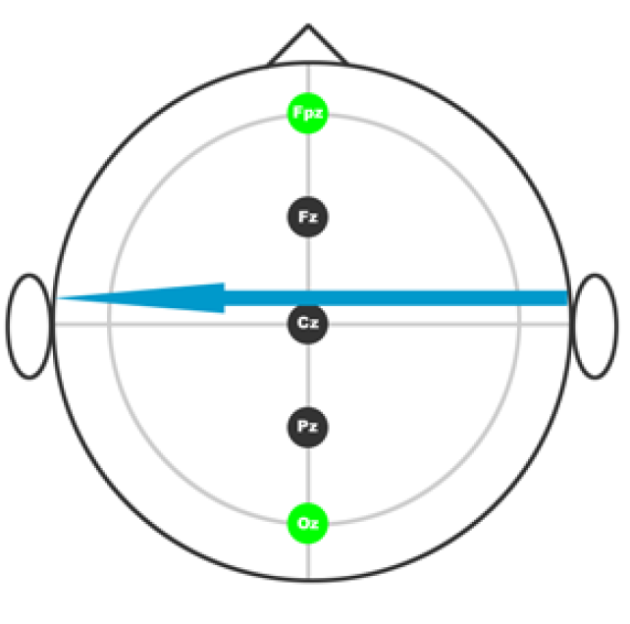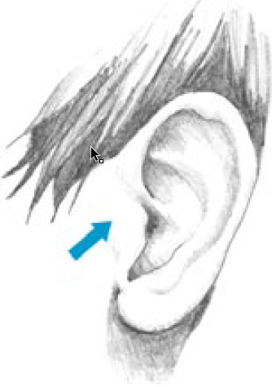

**Step 4:** **Confirming Cz location**

1. Measure and mark 50% of your total
2. At the intersection of your previous 50% mark from the Nasion to the Inion is your **TRUE** Cz mark.
3. For our example it is 38 cm / 2 = 19 cm.

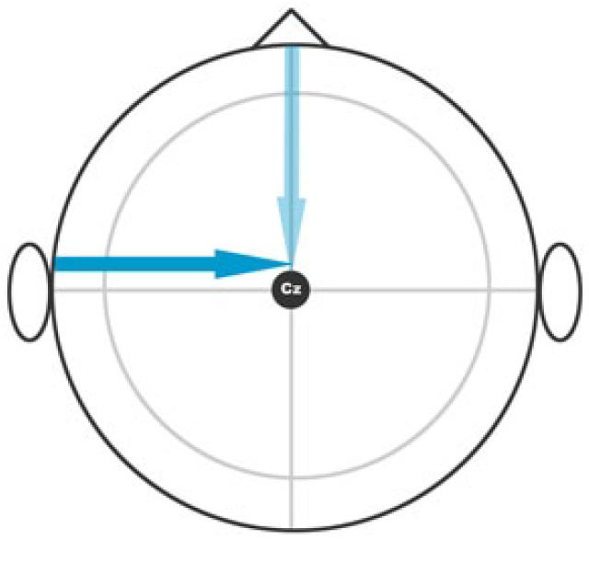

**Step 5:** **Head Circumference**

1. This is the easiest of measurements. Take your tape and measure the participant’s head circumference

At this point in your protocol you will be flip-flopping between the computer and the patient.

# Electrode Cap Placement

**Step 1:** **Placing the reference (ear) electrodes**

We always start by placing the reference electrodes because all the other electrodes are measured (referenced) to them. If you have an impedance diagram where most/all of the electrodes are showing high impedance, check your reference electrodes first.

**Step 2:** **Setting up the remaining electrodes**

Once you’ve placed the reference electrodes you can move onto the remaining electrodes.

1. Clean the area with rubbing alcohol and the Q-tip. While you are doing this you can swirl the Q-tip to clear hair out of the way. This can be particularly important with patients who have more hair.
2. Insert the gel. I would recommend using the “Pinch-N-Pull” method described below.
3. While you are doing this you should be checking the impedance figure in Cognionics. The electrodes should be turning green as you insert gel.

### Application Tips & Tricks : Pinch-N-Pull method

Ask any EEG technician how to apply gel and you’ll get a different answer everytime. I have utilized the “Pinch-N-Pull” method with great results. It can be useful to use when you have a subject with particularly large hear and while applying the gel.

**Step 1:** **Pinch-N-Pull**

1. This should be fairly self-explanatory but images are provided below. Notice how you pinch the electrode and pull up. This allows you to properly clean the underlying surface with a Qtip.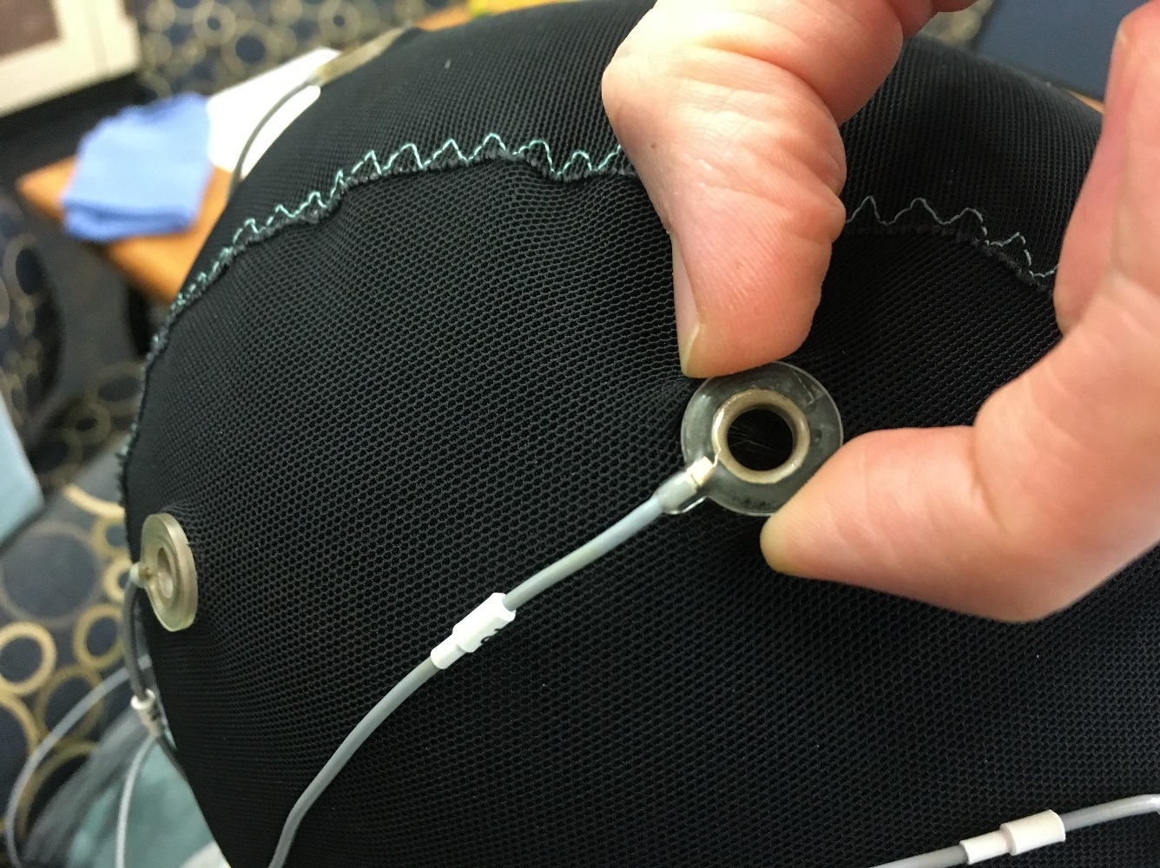  
   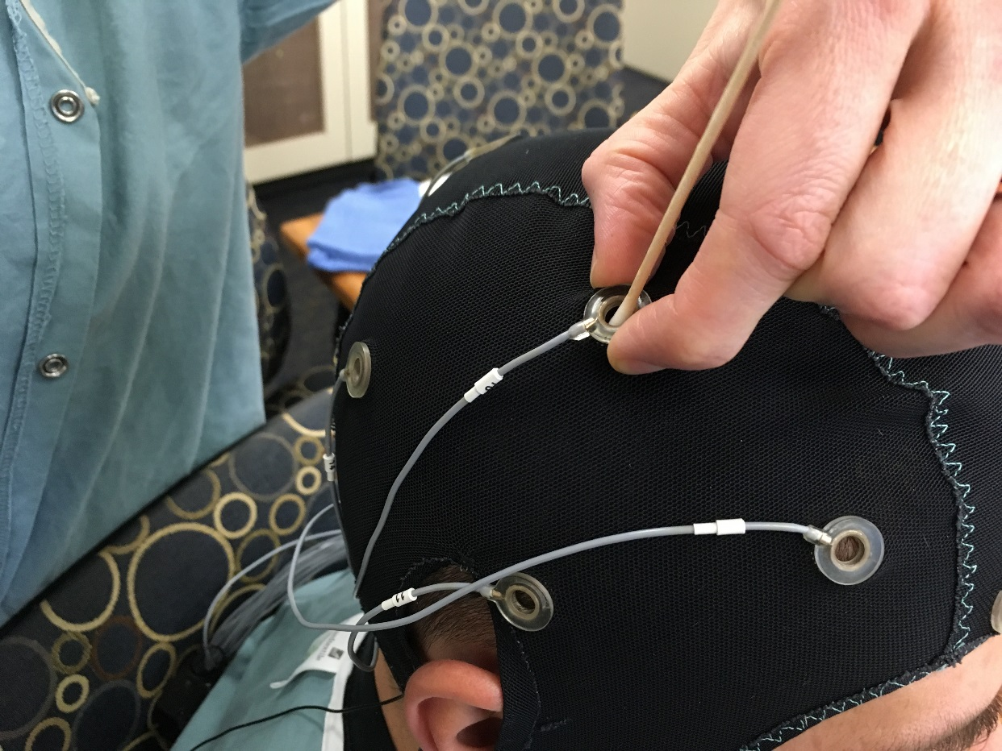
2. Again we would recommend pulling the electrode up slightly when applying gel. It can also be useful when you have one electrode with impedance levels that are slightly higher than desired.

# Starting a Recording with OpenBCI

Checking impedance signals

At this point your impedances should be good. Here are the next steps.

**Step 1:** **Viewing your EEG Signal**

Now you should be able to properly view your EEG signal in the window. If you find an aberrant electrode but are having problems locating it, Under the  tab, you can click on the channel on the right hand side. This will highlight the channel in blue, making it easier to identify. In this example I’m highlighting Fp1



**Step 2:** **Start Recording**

Under the Device tab click on Record. You will be prompted to enter a filename. Remember the location where you saved the data. You’ll need to access it later. Make sure you see the Time increasing (see second photo on the right).

**Step 3:** **During the Recording / Event Marking**

1. During the recording you will want to take note of any anomalies that occur. You can do this by taking note of it on paper while indicating the approximate time the error occurred.
2. A better way may be to add a Marker (see Marker tab) which corresponds to a “bad event”. In the Cognionics Acquisition software you currently can’t name each event (although we have contacted them about adding this feature). So for the time being it should be clearly denoted in your study’s protocol what each marker means. An example is shown below. You will also want to take note of these on paper since you will need to send them to Duan Li. These help her identify each event while she is analyzing the data.

|  |  |
| --- | --- |
| Mark Number | Label |
| Mark 1 | Beginning of preoxygenation |
| Mark 2 | End of baseline (end of pre-oxygenation) |
| Mark 3 | LOC (Loss of Consciousness) |
| Mark 4 | Placement of breathing tube |
| Mark 5 | Breathing tube removed (end of anesthesia) |
| Mark 6 | Two-minute PACU eyes closed start |
| Mark 7 | Two-minute PACU eyes closed end |
| Mark 8 | Artifact – Add details in written notes |

**Step 4:** **Stopping the Recording**

Click on Stop Recording under the Device tab. Your files will be saved in the location you specified when you started the recording.

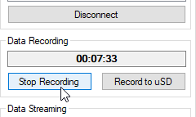

# Data Review & Cleanup

**Step 1:** **Gathering the Data**

1. Collect all your files and zip them. This should include a .vmrk .vhdr and .eeg file
2. Make sure you give it an appropriate file name

**Step 2:** **Start your email to Duan Li**

1. Attach your zip file to an email to Duan Li.
2. Make sure you CC other members of the team.
3. The emails title should be in the format Study Name + Participant Number
   1. 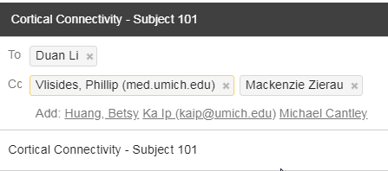
4. In the body of the email make sure to include marker information as well as any other pertinent notes. You may also choose to have these notes as a Word document. Other labs prefer using a Google Form.
   1. 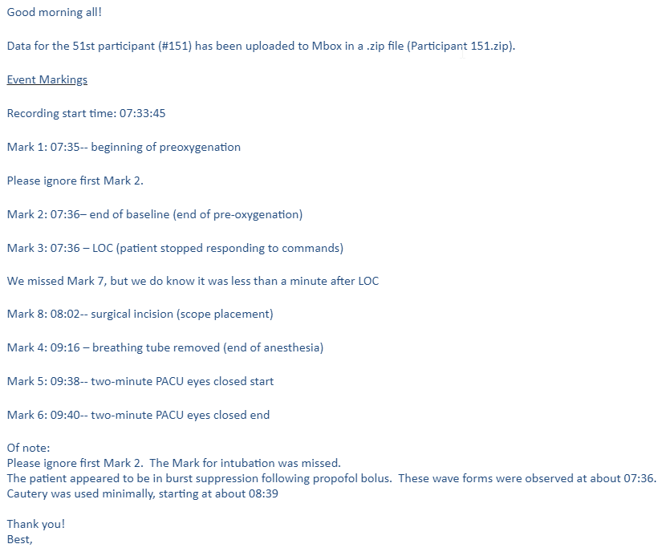

# Equipment Cleaning

**General Notes on Cleaning**

1. DO NOT LET ELECTRODES TOUCH METAL.
2. Clean immediately after use. Do NOT let gel dry on electrodes.
3. Remove electrodes from cap by gripping the plastic casing. Avoid grabbing by the wire.
4. Place the electrodes in a bucket of hot water. Keep the connector end away from the water – hanging around your neck works well.
5. Run each electrode under a fast stream of water for about 5 seconds.
6. When all electrodes have been thoroughly rinsed, place on a towel next to the sink. Fan the electrodes out and pat dry with a paper towel.
7. Do NOT soak electrodes in Cavicide.
8. Hang electrode sets in the side room; cover with a towel to protect from light.

**Step 1:** **Electrode Cleaning**

1. Clean immediately after use
2. Gather a Q-tip and Spaghetti strainer (optional)
3. Turn off the amplifier and remove the battery
4. Remove stickers by gripping the blue tab and plastic casing. Avoid grabbing by the wire.
5. Remove the electrodes from the cap  
     
   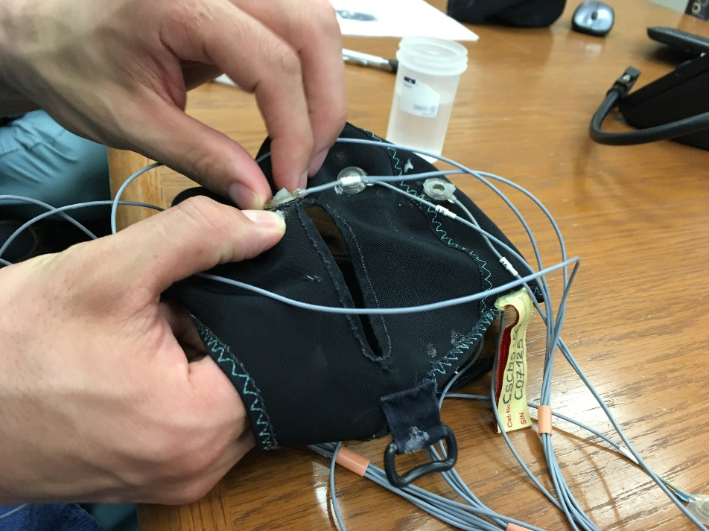
6. Rinse each electrode with a fast stream of water for about 5 seconds.   
   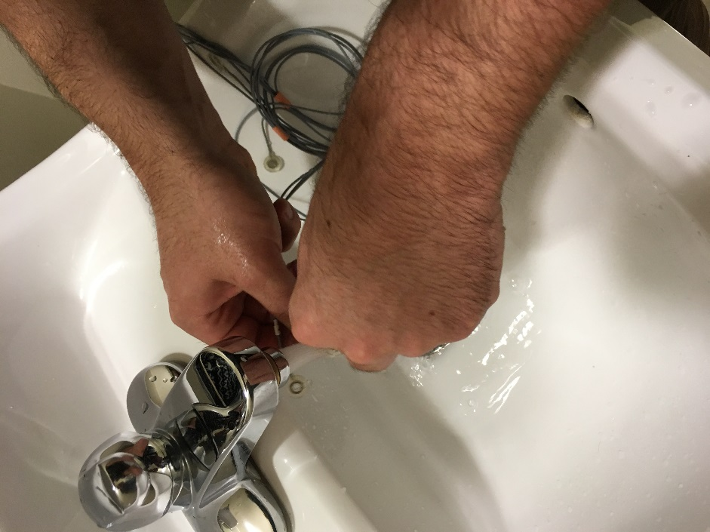
7. Use a q-tip to gently scoop any extra gel out of the electrode. A clean electrode is pictured below  
   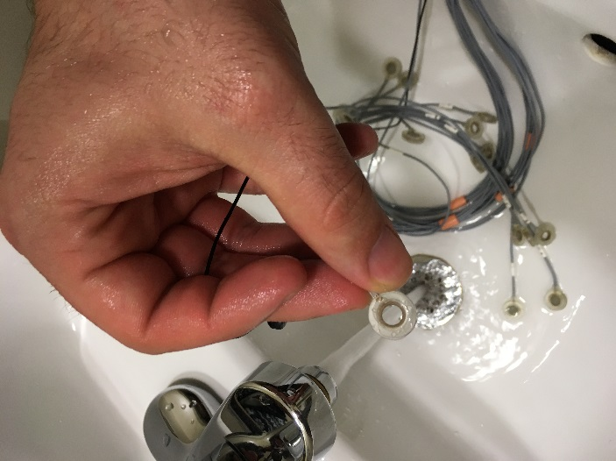
8. Re-rinse each electrode.
9. Hang to dry.
10. After several uses you may wish to clean the electrodes with Cavicide wipes. We highly discourage soaking the electrodes.

**Step 2:** **Cap Cleaning**

1. Rinse the cap under water and use your fingers to remove any excess. A before (left) and after (right) picture are provided below.  
   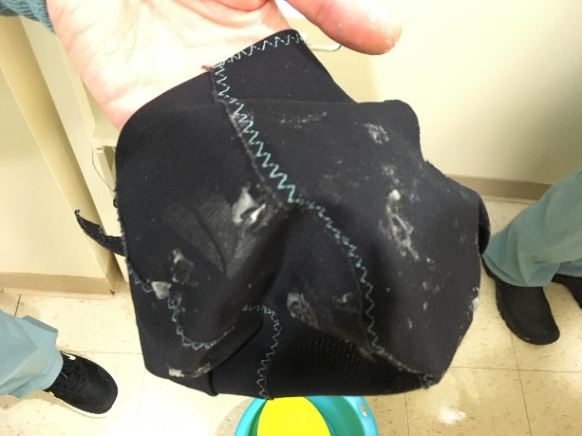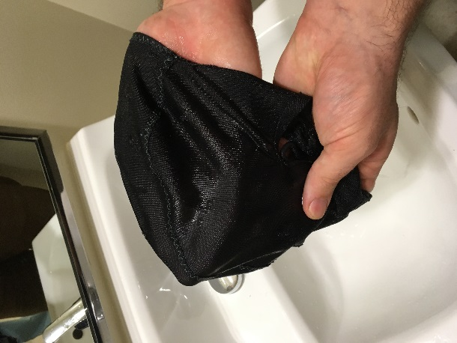
2. Soak cap and straps for 3-5 minutes in pure Cavicide using the bucket provided.  
   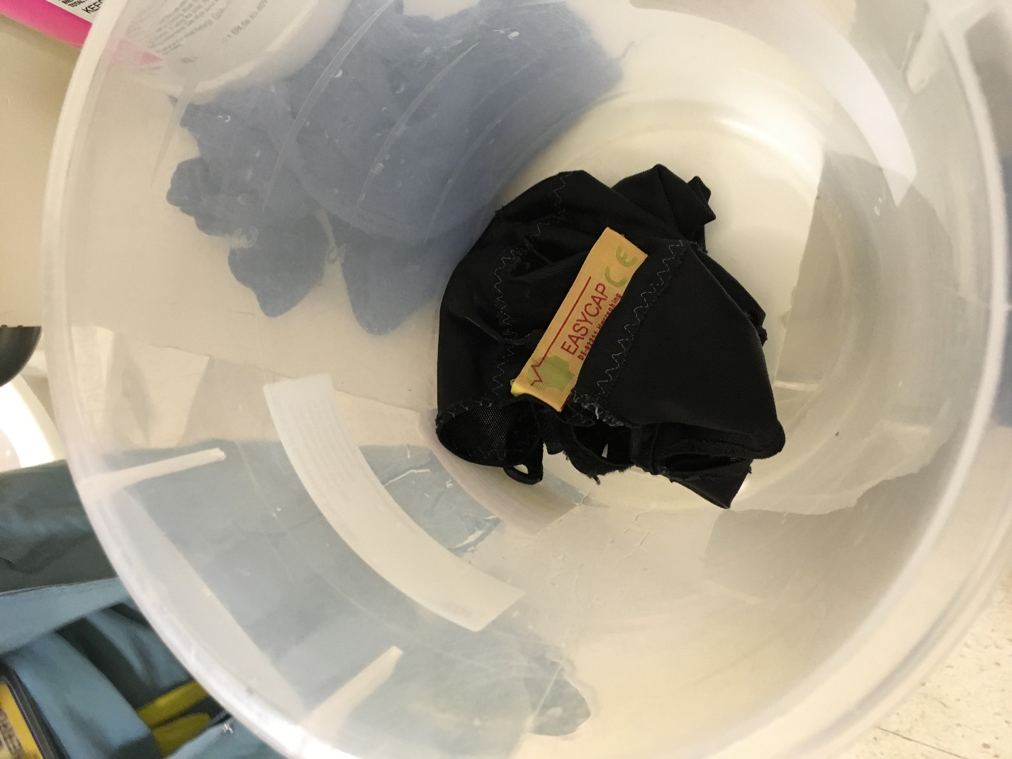
3. Rinse thoroughly with water. Hang to dry.

**The Remainder of this document is extra unedited text which I might add/review in future documents.**

# xElectrode Cap Placement

1. Perform electrode-cap insertion in the preoperative holding bay.
   1. Have person scrub their head as much as possible with thicker brush.
   2. Have person straighten their hair
2. Put cap on head of the person as snugly as possible (use cap size one step up if person is between sizes or definitely has a lot of thick hair)
3. Try getting the black mastoid reference electrode cleaned, scrubbed, and gelled first. The signal will look wonky at channels till it is in place.
4. Now make sure your cap is properly centered on the subjects head.
5. Check that left/right and front/back look even by looking from several sides. Adjust the overall cap as necessary. Try to be as consistent as possible across subjects in how the cap ends up. Here’s a good example, with a cap similar to ours, of how high up on the forehead the most frontal electrodes should be (Fp1 and Fp2). You can also estimate the Cz or measure it, and try to get the Cz on Cz regularly. It’s good to take notes on fit and placement in session log. **I would recommend going based off head measurements.**
6. Adjust chin strap well, making sure things are snug but not too tight. Ask the participant what’s too tight. Remember that pressure will “get worse” over time. This should not be a big problem if cap fits well.
7. At this point you can start the Cognionics software (**Cognionics Data Acquisition**), click the amp on, and you should see a green light on the usb stick. The software should allow you to Connect with the Device that it has detected. Say yes if asked whether to auto-configure. If you are just starting the prepping of the electrode sites, you can bring up the impedance window. **SEE RECORDING A SESSION for more details.**
8. In each electrode hole, clean, push hair out of the way, and swab the scalp by using the long q-tips dipped in alcohol. Twirl the qtip between your fingers once you’ve well reached the scalp.
9. In each electrode hole, put a large dollop of the grey gel (it’s abrasive) and twirl the qtip again in the hole Use just a little of the gel. Participant willing, be a little more aggressive in rubbing each site. You are gently abrading the scalp to maximize signal quality. Do not press super-hard as it is not necessary in any way. Use only the soft head of the Qtip. Do not twirl too fast or too hard as it can burn the participant.
10. After that, fill each electrode hole with a column of the grey gel. Start the column from deep within the hole, touching the scalp. Make sure that the gel puddles out and makes contact with most of the scalp at that electrode location. Then keep pushing out gel as you move the syringe out of the hole, again making sure to fill out the hole well. The goal is to make a solid good column of gel from the scalp to the top of the electrode. The hole needs to be filled, you don’t need to put so much gel that you cannot see the electrode ring. If you’re not sure if it’s great, putting a little more gel into the hole won’t hurt. However make each gel application count, so that you’re sure that you’ve done what you can to maximize the signal there.
11. After having gelled all channel locations, check the impedances (**Channels Tab**), trying to fix locations as necessary (maybe requiring a little more gel). Impedance viewer settings are set to display a red color for any given channel with too high of an impendence. If impedances are not low to begin with, impedances should usually come down over time.
12. Single small pieces of tape can be put over each electrode hole when application is finalized.
13. The most important aspects are making sure to prepare the electrode site properly with alcohol and the abrasive gel, and by making a full good column, and really making sure there is full contact and spreading of the gel on the scalp at the electrode hole. With good skin contact and a good gel column, the signal will be as best possible.

# xHandling Participants

This section is meant to give you some general pointers on how to handle certain situations. It can be useful for those who are conducting this form of research for the first time by providing an example of suggested language.

### Appointment Prep

* Gather materials: electrodes (left and right electrode bundles, 6 face electrodes, and CMS-DRL electrodes), Velcro straps, measuring tape, face stickers, sanitizing wipe, gel, syringe(s)
* Fill two disposable syringes about halfway with gel
* Place stickers on the face electrodes

### Bring the participant in

* The participant (or their parent) will call the lab phone
* Ask where they are - parking structure, which door - meet them, and escort them in
* Ask if they need to use the bathroom in the next hour and a half.

***“Do you think you'll need to use the bathroom in the next hour and a half or so?”***

### Explain the process to the participant

***“Have a seat in the wooden chair. I'll explain everything we're going to do here today before we get started. Feel free to ask any questions throughout the appointment.***

***I’m going to attach all these electrodes (show electrodes) to your head and face.***

***I’'ll use this cap (show cap) to attach most of the electrodes to your scalp - they plug into these holes.***

***I'll use a bit of this gel (show gel) in each hole to help the electrodes connect to your scalp and get a clear signal. The gel is water based, and is easy to wash out of your hair.***

***A few electrodes will go around your eyes and behind your ears to measure your blinks and head movement. They'll attach with a sticker, and also have a bit of gel on them.***

***Once I get all the electrodes attached, you'll go into the chamber to do the task. It's sound-resistant to reduce distraction.***

***The task is simple - you'll be pushing arrow keys for which way you see arrows pointing on the screen.***

***Setup should take about 20-30 minutes, and the computer task should take about 45 minutes to an hour.***

***Does that sound alright? Do you have any questions?”***

### If they seem nervous

* Remember that their assent/consent is REQUIRED; if they don’t want to proceed they don’t have to.
* Reassure them that no part of the process hurts
* Explain each step before you start, making sure they’re still comfortable
* Let them know that they can stop at any time.
* Encourage them to continue:

***“Is it alright if we put on the cap and see how you feel?” or “What do you think about trying out the practice block and seeing how it goes?”***

### Setting up

***“To start, I’ll measure your head to see which cap to use and to help us align the cap on your head.”***

* Measure head from nasion to inion (in cm), wrapping measuring tape over head from between the eyebrows to the small bony protrusion on the back of the head (inion)
* Measure head circumference (to the millimeter), wrapping measuring tape around forehead and back of head.

***“I'll start with the facial electrodes. I'm going to use an alcohol swab to prep the skin; it helps the electrodes stick. You might want to close your eyes because it can be a bit fumey.”***

* Wipe areas where face and mastoid stickers will be applied with alcohol wipe

***“Now I’ll put the facial electrodes on.”***

* Apply face electrodes, with gel, according to diagram on the chamber

***“Now I’ll put the cap on.”***

***“I'm going to measure to make sure it's aligned just right. Does this cap feel comfortable?”***

* Put on the cap and use measuring tape to ensure that Cz is located at approximately half the N->I omeasurement (Ex: 36 cm= 18 cm), and that Fz is located approximately 10% of N->I up from the nasion. (Ex: 36 cm=3.6 cm)
* Attach Velcro straps

***“Now I'll put some of this gel in each hole. It'll feel a bit cold, but it shouldn't be uncomfortable. (for long hair) I'll need to wiggle the applicator around to get the gel through your hair and down to your scalp.”***

* Fill the holes of the cap with gel, making sure to spin/wiggle the tip of the syringe around in order to reach the scalp through the hair

***“Now I'll plug all the electrodes in.”***

* Plug in each electrode to corresponding hole in cap

***“Now I'll bundle all these wires up so they don't tangle.”***

* Wrap the CMS-DRL cords to around the other wires and secure with black Velcro loops

**“*Okay, you can get up and head into the chamber; I've got all the wires. Go***

***ahead and get comfortable in the seat. You want to be sitting so that you can comfortably have your right and left pointer fingers on the right and left arrow keys.”***

### Plugging in electrodes, preparing for the task

***“I'll plug in the wires, and we can see how the signal looks.”***

* Plug in all the electrodes, turn on the box, troubleshoot electrodes (see troubleshooting guide)

***(if adjustment is necessary) “I need to add more gel to (one/a few) electrode(s).”***

* Demonstrate to the participant the importance of keeping still by asking them to blink and clench their jaw while showing them our computer screen. Explain that muscle electricity with movement will interfere with our ability to monitor electrical activity of the brain.

***“Look out here at this screen. Each colored line is the signal from one electrode. I want to show you what it looks like when you move. Go ahead and clench your jaw like you’re chewing. See the noise here? Go ahead and blink really big several times. See the waves? Muscle activity makes a lot more electrical signal than brain activity. I’m showing you so you can see why it’s important to hold your head and face still during the task. Movement can drown out the brain signals I’m trying to record.”***

* Start the welcome scenario and explain the task

***“For each trial you’ll see five arrows on the screen. You’ll respond only to the central arrow. If the center arrow is pointing left, press the left arrow key; if it’s pointing right, press the right arrow key.”***

***“It’s important that you try to blink as little as possible. Don’t worry too much about it; if it seems like you’re blinking a lot we’ll take a break so you can rest your eyes.”***

***“Answer as quickly and as accurately as you can. As we’re going through the task, I may ask you to focus more on speed or focus more on accuracy, but it doesn’t mean you’re doing anything wrong.”***

***“Now we’ll go through a practice block, to make sure you understand the task and the signal looks good. For each trial, you’ll see a plus come on the screen, and then the arrows about a second later. Press which way you see the middle arrow going.”***

***“Sound good? Is it alright if we close the door most of the way during the blocks? Okay, let’s get started.”***

* Leave door ajar when exiting the chamber to begin practice

### After practice block

* Check in and confirm the participant understands the task

***“How did that go? Does the task make sense?”***

* Offer feedback and clarify if they got a high number of errors, like:

***“Just to make sure, you’re responding to the middle arrow, right?”***

* Let them know how the task will proceed

***“Okay, we’re going to do 8 blocks of the same task. We’ll check in between each one, and after four we’ll take a bit of a break and you can have some water and fruit snacks if you like. I need to set up the file to record, it’ll just take a minute.”***

* At the beginning of the 1st block recording, have the participant blink and move eyes side-to-side several times

***“Before we start, can you blink several times? Now, holding your head still, can you move your eyes side to side several times? Thanks.”***

* Begin 1st block

***“Are you ready to start? Okay, it’ll be on your screen in a moment.”***

### Between trials

* Check in with the participant to make sure they’re still comfortable
* Troubleshoot any noise: i.e. add gel, remind participant to try to hold still
* If errors are between 4-9, proceed as usual
* If errors are 10 or more, ask to focus on accuracy (If errors are quite high – 15-20 or more – double-check task understanding
* If errors are 3 or less, ask to focus on speed

***“For the next block, focus on answering quickly.” -or-***

***“For the next block, focus on accuracy.”***

### Break

* After the 4th block, offer fruit snacks and water; remove bottle/wrapper after break
* If the participant prefers to continue without a break, that is fine

### Tips

* If a participant is using their phone during setup, it’s best to ask them to leave it outside the chamber while they do the computer task
* If a participant is uncomfortable with the door closed, leave it open. Prop it so it’s as open as possible without them seeing our computer screens - they can be distracting
* Do not ask participants where they heard about the study, or anything about their diagnoses.

# xRecording A Session

1. At start of recording, make note of high-impedance in any of the channels.
2. Start recording. Give appropriate name to recording file (**EnrollmentID#**).file extension.
3. Begin **baseline, eyes-closed** recording session (**2-minute eyes-closed period**). Use **Mark 1\*** in the **Markers** tab of the software program. (1) Make sure the curtain is closed, (2) make sure no one is speaking in the preop bay at the time, and (3) keep lights on – this will probably be easier and more realistic in terms of experimental consistency (plus, lights will also be on in the OR and PACU). As much as possible, ensure that no one else is in the pre-op bay speaking with the patient. If this period is interrupted (i.e., surgeon coming in to chat with patient), that’s okay. Participant can stop and engage in conversation. Re-attempt to start 2-minute eyes-closed session afterwards, and just keep a log (paper and/or on the computer) of the timing of these sessions. Ultimately, **make sure you have logged the correct (based on the *computer clock*) time of the full, eyes-closed 2-minute baseline period.**

**\****Note: for each event recorded during the entire experimental procedure, use “Mark 1” – this will help with experimental consistency, and we can always make a note of what that “Mark 1” entailed at the time (e.g., 2-minute baseline recording begin/end, loss of consciousness, return of consciousness)*

1. It’s recommended to stay at some distance (~2 to 3 feet) from the participant and to minimize crowding and electronics around the participant.
2. Follow patient into the operating room. Ensure that you have a mask and scrub cap on for appropriate OR attire.
3. Once settled in the OR, try to stay at least 2-3 feed away from participant, sitting in a stool (if you can find one) so that you’re not in the way of the anesthesia team.
4. Shortly after the anesthesia team begins giving anesthetic medications, mark **loss of consciousness** (again **Mark 1**) after this patient stops responding to commands. This will entail the anesthetist asking questions like, “are you warm enough? How are you doing?” and not hearing a response. Then, the anesthetist will reach for a green bag to start breathing for the patient. When you see this sequence of events, hit **Mark 1 (**and record **loss of consciousness**).
5. Continue recording via the cognionics computer interface, checking impedances, issues, etc. If at any point you need to adjust electrodes, just check with the anesthesia team first to make sure it is safe to approach the patient to do so.
6. Routinely double-check that the USB stick with the green light is firmly in (I recommend putting some tape on it to make sure it’s not knocked out), battery life is okay, etc. If battery life is running low, **text/page a teammate for a new battery**. There should be plenty of electrical outlets as well in the OR for the laptop computer.
7. At the conclusion of surgery/anesthesia, the anesthesia team will discontinue all anesthetic medication. Our practice here is to ask patients to “squeeze our hand” when they have once again become conscious. When this happens, and they are squeezing the anesthetist’s hand and/or following commands, **mark return of consciousness (Mark 1).**
8. Accompany patients to the recovery unit. Once the “dust settles” and the patient is stable (check with the nurse) perform our **post-surgery, eyes-closed 2-minute recording**. This is done *just* like the baseline, 2-minute eyes closed period above. Make sure times are recording accurately. You’ll likely have to wait at least 15-20 minutes to do this test, as the nursing staff usually needs 15-20 minutes to get the patient stable, settled, etc.

# xUsing the PC and Software

Password: excelsior or Excelsior

When recording, have no other programs running

When recording, also have the Wi-Fi turned off. Network settings are available in the lower right toolbar

The extra drive has 1 TB data storage, so the computer should serve as Repository #1 of appropriately named data recordings, which should also be copied elsewhere after each run (i.e., to the shared online folder via USB stick from the PC to a networked computer).

There is Google Chrome on the PC in case web access is needed.

MATLAB, EEGLAB, and CARTOOL have been loaded for reviewing the data as necessary

All “necessary” programs are in the lower toolbar.

IT IS NOT RECOMMENDED that any Microsoft or other products be installed. **The PC should be only for recording, temporary data storage, and data review**.

Click the Cognionics icon on the toolbar at the bottom of the desktop.

This will open the Cognionics Data Acquisition Window at the **DEVICE TAB**. If the USB is plugged in and the amp is powered on, the Cognionics Wireless EEG D21130 Device should be detected, the gel wireless electrode set.

Leave the accelerometer checked On. Click Connect. It should ask whether to Auto-configure, click Yes.

You are now in the Cognionics Device Configuration window. You should see 16 channels ordered as expected in a list and a spatial map. Samples should remain at 500. Amplifier gain can stay at 3. Input is Normal. Click Write to Device and Start. You should see evidence of signal in the Raw EEG display tab. It will look crazy if impedances are not done or values are being shown at an innacurate scale.

When you want to start to record, click RECORD. Select a filename, location, and filetype. Use EDF files for the time being. Click STOP RECORDING to end the recording for that data file.

Click the DISPLAY tab in order to modify time scaling to 10, and scale the EEG as necessary. You may also show yourself some or all channels, or have two pages each with a subset of the channels. FILTERING is recommended for viewing the signal at 1-40 hz. One should toggle between 1-40 hz and 1-100 hz just to see what things look like after one has done impedances and is ready to record. Looking at the signal without the 100 hz lowpass filter can help you detect degree of noise in the signal.

Get familiar with all buttons and tabs in the software, so there is no learning curves or mistakes once recording starts.

During pre-testing/piloting one should play around with some settings to see what they do, as they may come in useful during recording (for example you may have an extrme channel that you want to mask out with mask Hi-Z channels.

The CHANNELS tab is where to go see the channel list, see current impedances and voltages. Click on the little area in the lower right of the Channel Impedance display to be able to maximize it, so as to read values easily during prepping, and as necessary during recording. Full screen impedances while doing impedances is storngly recommended.

Markers allows one to click one of 8 markers that will “show up” in the recorded eeg.

The accelerometer recording will be useful to track movement.

The ASR TAB is used if one wants to record a baseline period that is used to “clean” up subsequent data that is recorded during the session. One can save a new ASRed file, and one can view the ASR cleaned signal. Please consult with Tarik or Brain Vision for more info on this method. One can try it with no effect on the raw data that is being recorded.

# Starting a Recording (EEG, EMG, ECG)

**Step 1:** **Set up**

* **EEG**

1. Connect all the electrodes (except reference and ground electrodes) to the mainboard’s (Cyton + Daisy) 16 channels. For both Cyton and Daisy, connect only bottom pins of 1p-8p to electrodes.
2. Use a Y-splitter to connect both SRB bottom pins to reference electrode.
3. Connect the bottom pin of BIAS (either Cyton or Daisy) to ground electrode.

4. Plug the Cyton to battery.

* **ECG**

1. Connect the ECG (pulse sensor) to the mainboard. Black wire to GND, red wire to VDD, and purple wire to D11.

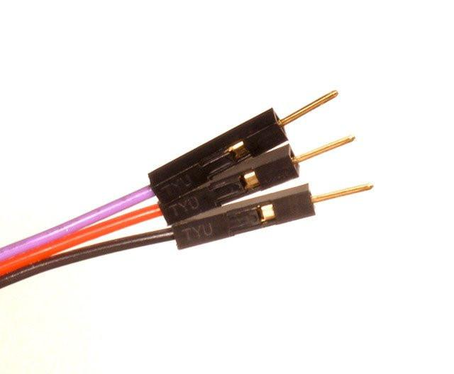

**To black**

**To purple**

**To red**

* **EMG**

1. Clip the pre-gelled electrodes onto EMG.
2. Connect the EMG to the mainboard. “+” to VDD, “-”to GND, “SIG” to D12.

Note: (i) For simultaneously working of EMG and ECG, GND and VDD can be shared by using Y-splitters. (ii) EMG signals can also be obtained by connecting one of the 16 high resolution channels. Connect R to BIAS(top pin), E to any top pin from 1p-8p, and M to corresponding bottom pin.

1. Place EMG along the longitudinal midline of the desired muscle with the arrow parallel to the muscle fibers. DO NOT place the sensor at the outside edges of the muscle. DO NOT place the sensor on or near the motor point. DO NOT place the sensor on or near the tendon of the muscle.

**Step 2:** **Data recording**

1. Turn the switch of mainboard (Cyton) to PC. Turn on the switch of EMG. Plug the USB Bluetooth dongle into computer. If using the WIFI shield, insert the WIFI shield between Cyton and Daisy, connect another set of battery, and turn on the switch of WIFI shield. (Setting up of WIFI shield refers to OPENBCI online tutorial : <https://docs.openbci.com/docs/01GettingStarted/01-Boards/WiFiGS> )

1. Open the software of OPENBCI. A screenshot of a cell phone

   Description automatically generated

Choose LIVE (from Cyton) — Serial (from Dongle) (choose WIFI if using WIFI shield) – Corresponding Serial # -- OpenBCI – 16 CHANNELS, and then click “START SYSTEM”.

In Time Series plots, Channel 1-16 indicates EEG (Channel 1-8 correspond to Cyton 1p-8p, Channel 9-16 correspond to Daisy 1p-8p). In Analog Read, A5(D11) indicates ECG, A6(D12) indicates EMG.

1. To start recording, click “Start Data Stream”. In Analog Read, click “Turn Analog Read On” to virtualize EMG and ECG signals.

Note: If Analog Read is not open on the interface or not turned on, EMG and ECG signals will not be recorded.

1. To live stream data, open Networking, choose “LSL” in Protocol. Turn the desired stream on, and click “Start”.

